校內戒菸輔導區
Smoking Cessation Assistance Area
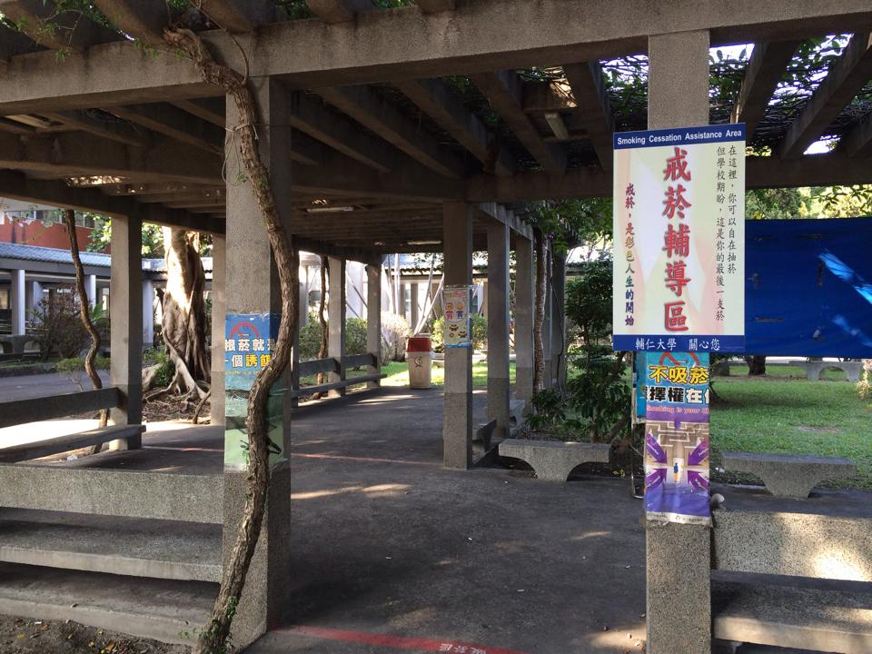  仁園餐廳前、濟時樓走道旁休憩區Near Msgr.Fahy Memorial Buildingre | 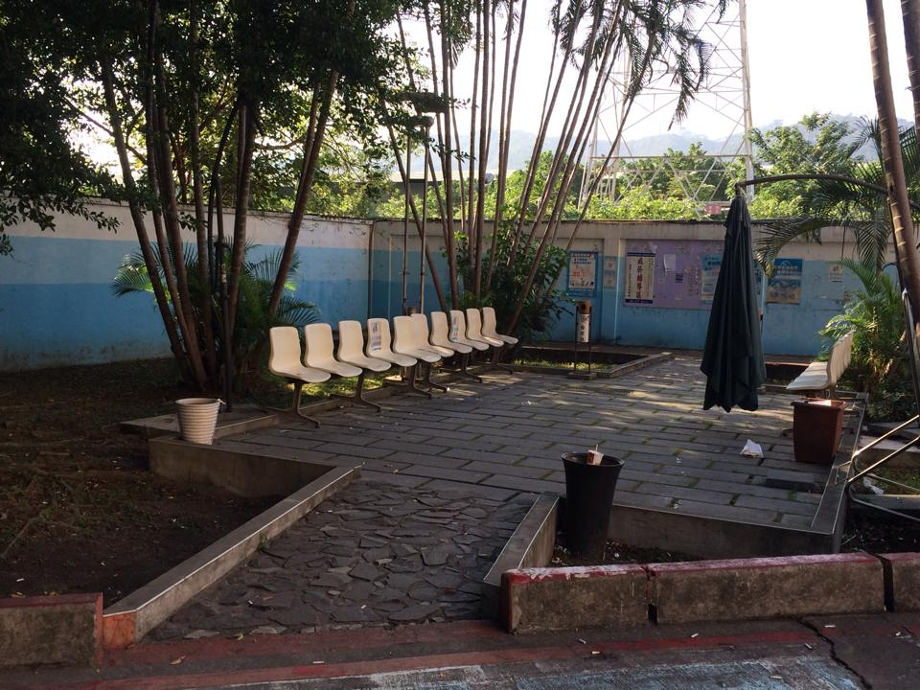  聖心實習旅館旁空地  Near by St. Sacred Heart Teaching Hostel
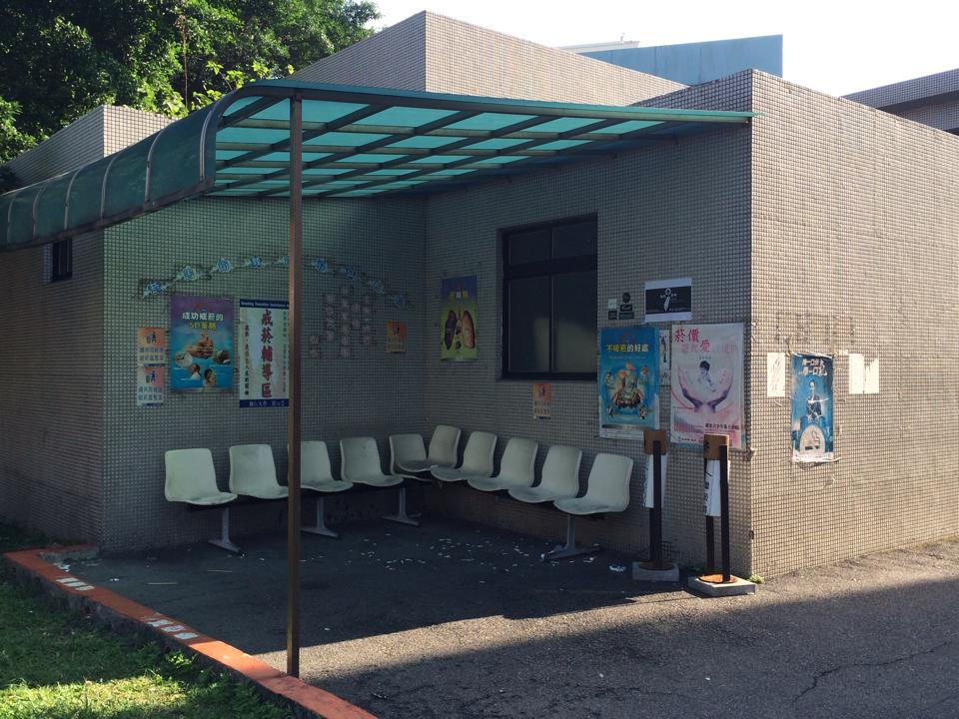  文開樓東後側（車庫後方）  Near Liberal Enlightment Hall | 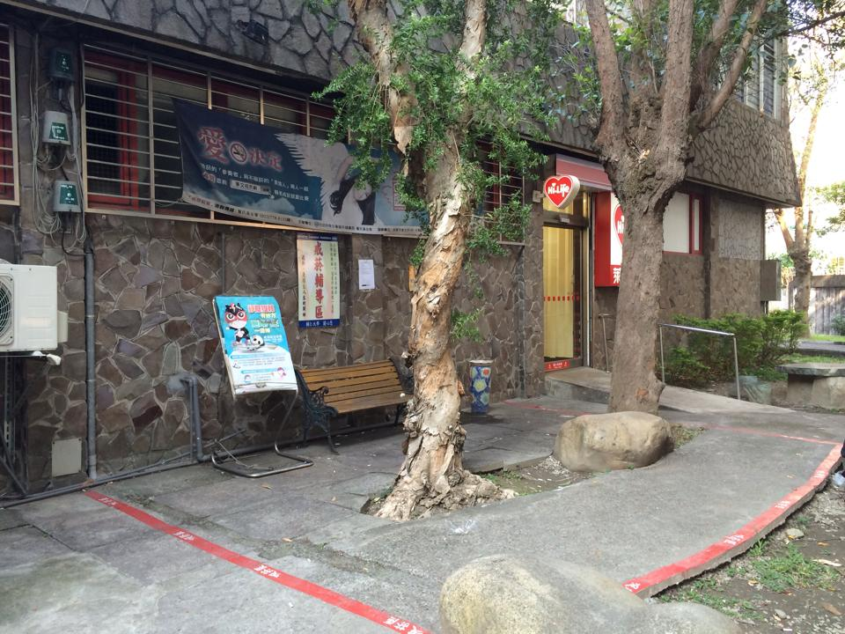  萊爾富旁石桌椅休憩區內  Next to Hi-life Convenience Store
- 為維護健康學習環境，抽菸者請配合至「戒菸輔導區」抽菸
To maintain a healthy learning environment, No smoking except at Smoking Cessation Assistance Area.
守護無菸害校園，你我有責
To establish a smoke-free campus greatly demands your cooperation.
學生事務處 關心您

